EEM Release Notes

for

Version 3.17 released as of

29/06/2018 07:07AM

Table of Contents

1. Introduction 3

2. Compatible Products 3

3. Installation Steps 3

4. New Features 3

5. Bug Fixes 4

6. Known Problems and Workarounds 4

# Introduction

This document communicates the major new features, bug fixes and setup changes in this release of the EEM. It also documents known problems and workarounds.

# Compatible Products

This release has been tested on the following platforms and products:

* Windows OS 2012 on the Server
* Windows OS 7.0 on the Client
* MS SQL Server 2012
* Internet Explorer 11

# Installation Steps

* Backup the EEM Production Binaries for future use
* Download the Release rar files from the git hub.
* Stop the EEM Production Website on IIS
* Extract any one rar file which will automatically extract all required EEM binaries and related files.
* After successful extraction, copy the files to the EEM release location on the EEM server.
* Go to the Scripts\Upgrade folder in the released location and run Setup.cmd
* Restart the EEM Production Website on IIS

# New Features

* 1. **Feature Description:**

Auto notification for employee leave. send notification mail prior to the vacation date

Mail 1 - Send to the employee's team members (get from module chart)

Mail 2 - Send for the employee to make sure all the assigned tasks are planned accordingly

**Job Setup:**

* + You need to schedule the SQL job to run daily using Manage jobs feature.
  + Go to Tools -> Configuration -> Manage Jobs, click on Manage regular jobs tab.
  + Click on add job icon and select SQL execution job type
  + Enter execution script as " DECLARE @runDate DATETIME = GETDATE();

EXEC Emanager..Esp_Auto_Leave_Notification @runDate".

* + Schedule the job to run daily at 10 AM.

**Example:**

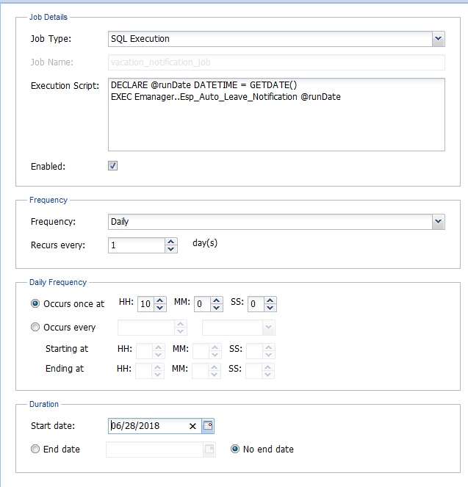

# Bug Fixes

**5.1 Bug Description**

Can we allow user to see status for recent accomplishments in MSM

**Changes:**

Status window was not allowed for the recent accomplishments band in MSM. Which is now allowed and shows a non-editable status window.

# Known Problems and Workarounds

None